UNIT 7

Practice 7.1
Windows Network Management


Jesus Ballesta Bernabé 1ºDAM

2. Development of the activity.

2.1. Description of network commands.

Find information for the following Windows console (cmd) commands:

Nº | COMMAND | DESCRIPTION
1 | ARP
2 | FTP
3 | GETMAC
4 | HOSTNAME
5 | IPCONFIG
6 | NBTSAT
7 | NET USE
8 | NETSH
9 | NETSTAT
10 | NSLOOKUP
11 | PATHPING
12 | PING
13 | ROUTE
14 | SHUTDOWN
15 | SSH
16 | TASKKILL
17 | TELNET
18 | TRACERT
19 | WGET
20 | WINRM
2.2 Network configuration.

1. Capture screen Network Configuration IP version 4:
• IP Address: 192.168.3.<nºPC+30>
• Mask: 255.255.255.0
• Default Gateway: <DGW> The gateway is the same as the one that appears in the configuration stick of the host PC.
• DNS Servers: 8.8.8.8 – 8.8.4.4. – 1.1.1.1
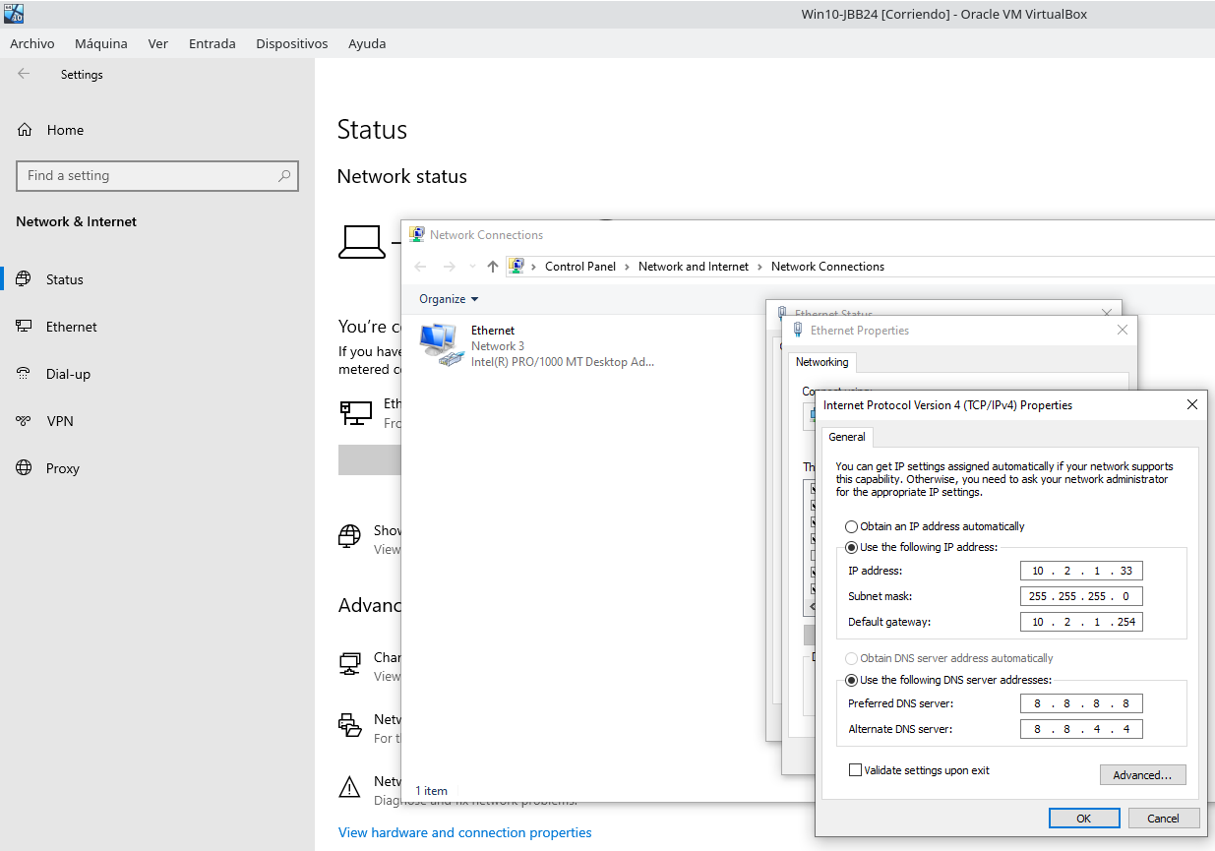

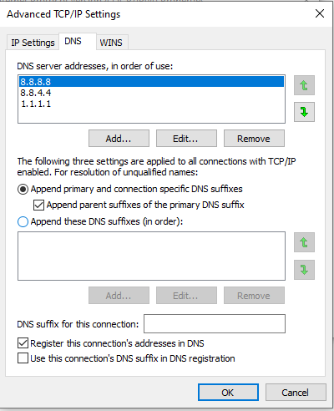

2. Get TCP/IP network configuration data with ipconfig.
C:\Users\student-<codId>> ipconfig
C:\Users\student-<codId>> ipconfig | find “IPv4”
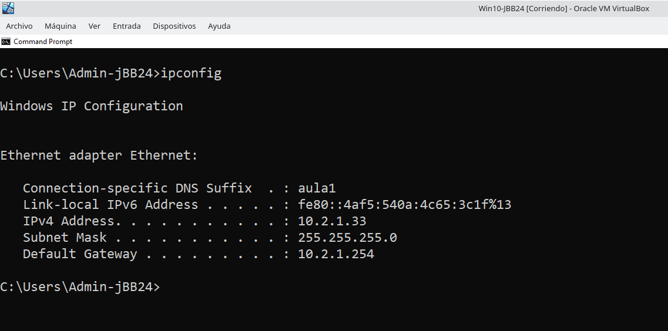
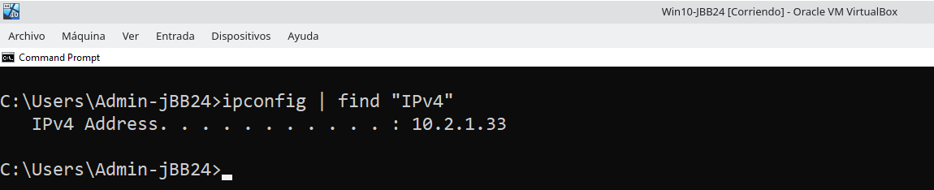

3. Disable Windows Firewall

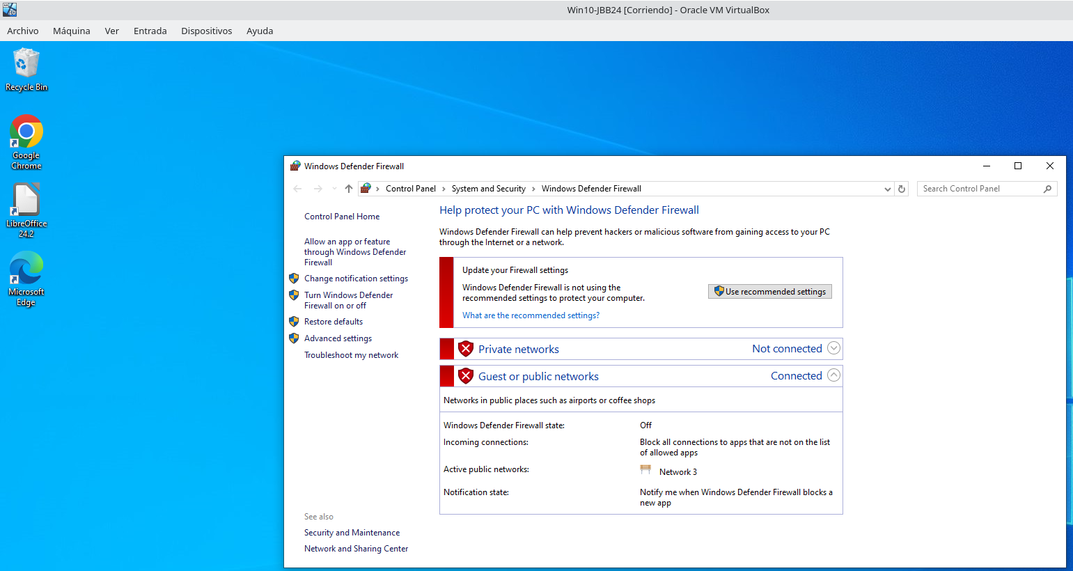

4. Disable Windows Updates

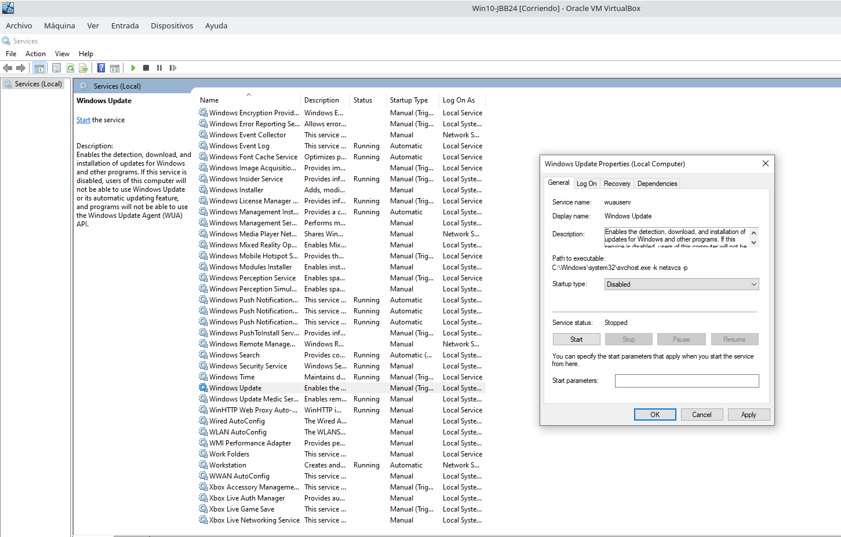

5. Check the connectivity between the host machine and the Windows 10 guest operating system. Use the ping command on both machines.

Windows 10:
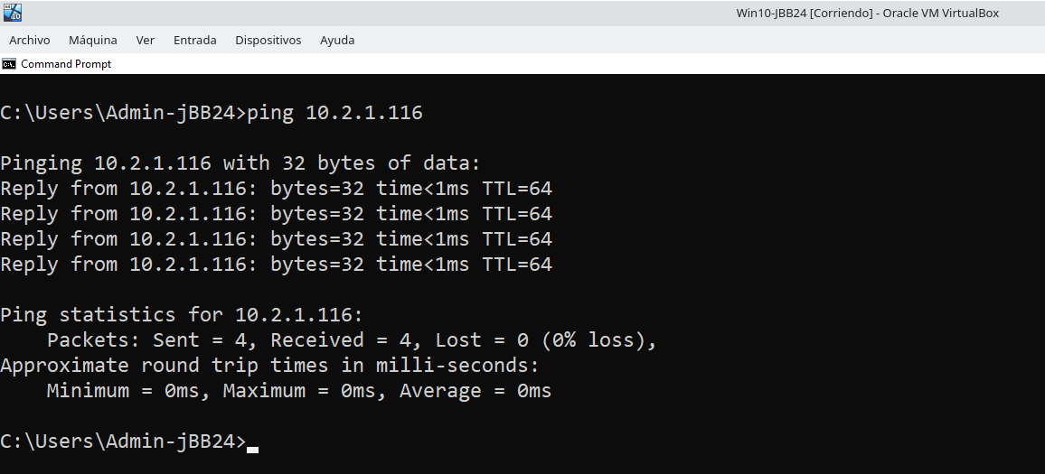
Host:
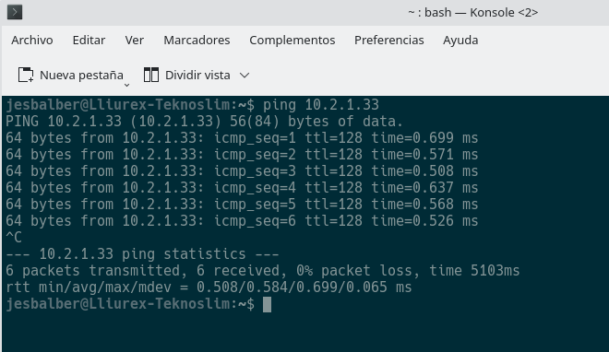
2.3. Basic network commands in Windows.

6. Launches a connection request to the address 8.8.8.8, which represents Google's DNS, to which it should always respond, from which, if it works, we can deduce that it is being reached correctly and that there is good connectivity. (XXX = 5 + <nº PC>)

C:\Users\student> ping -n XXX 8.8.8.8
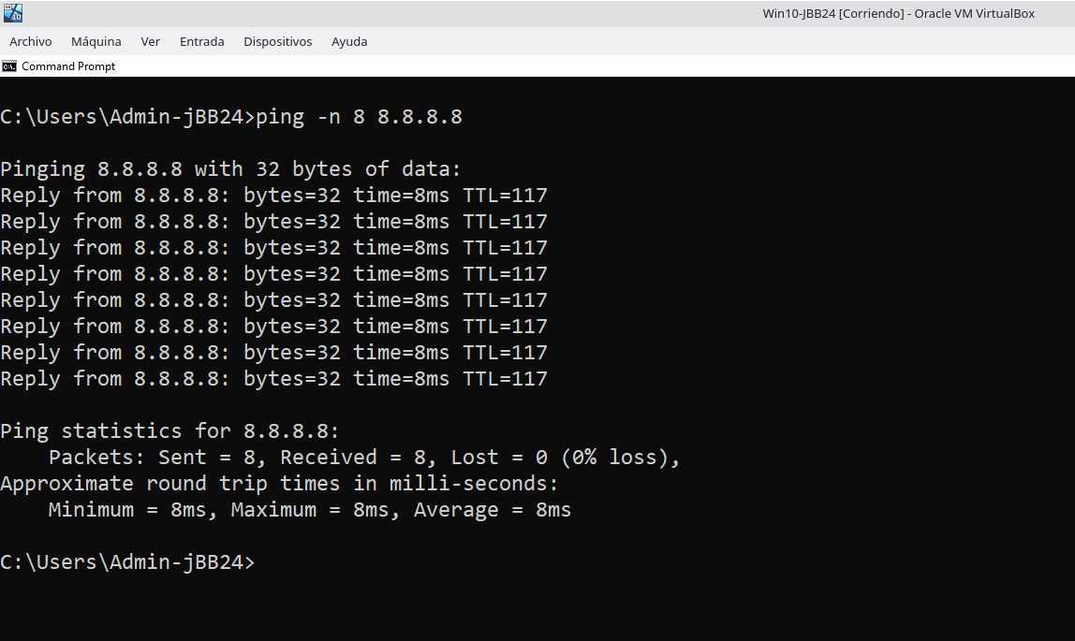
7. Shows the name of the current host.
C:\Users\student> hostname
Make sure the machine name is W10-<codId>
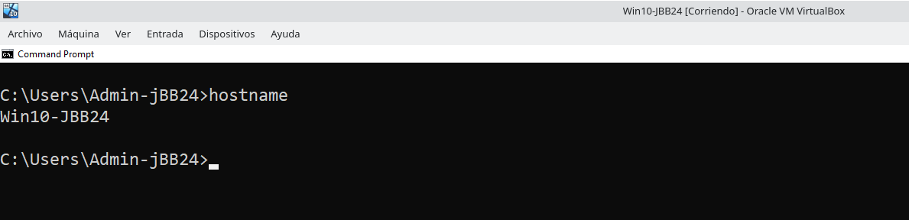
C:\Users\student> echo %userdomain%
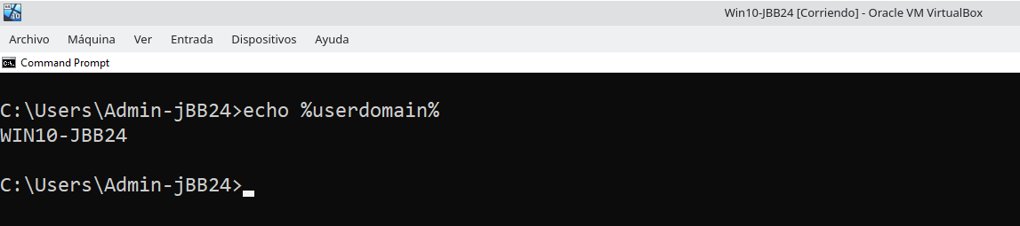
C:\Users\student> ipconfig /all | find “Name”
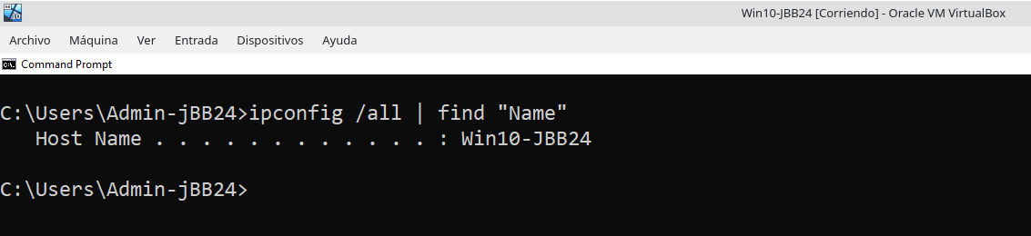
8. Obtains the MAC (Media Access Control) addresses associated with the network adapters.

C:\Users\student> ipconfig /all | find “Physical”
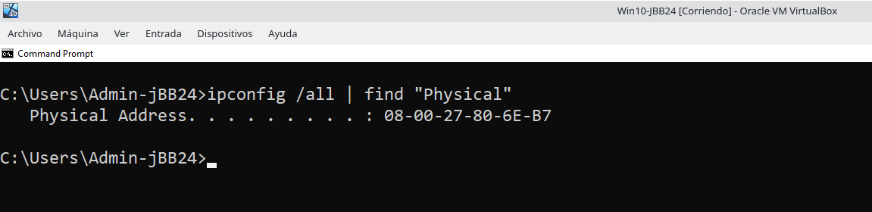
C:\Users\student> getmac
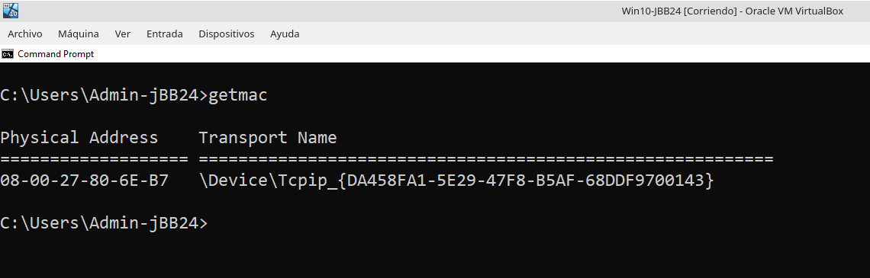
9. Displays and modifies the tables for converting IP addresses to physical addresses used by the ARP (Address Resolution Protocol) address resolution protocol.
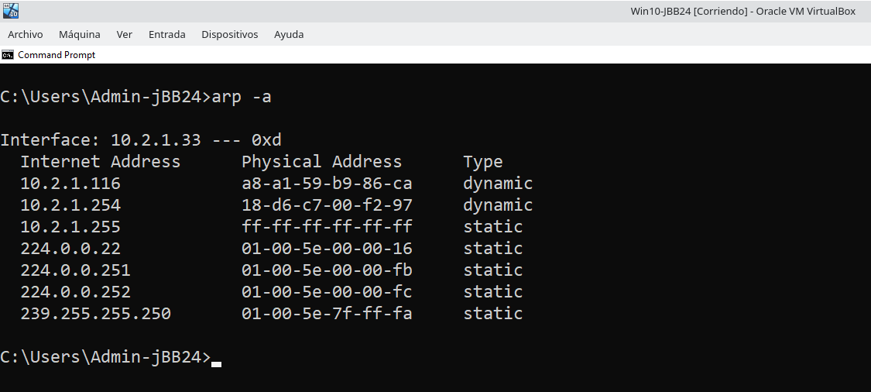

10. Explain the difference between a static and dynamic type ARP entry.

11. Explains the operation of the nslookup command.

C:\Users\student> nslookup /?
C:\Users\student> nslookup www.marca.es
C:\Users\student> nslookup www.ua.es 8.8.8.8
C:\Users\student> nslookup www.ceice.gva.es 8.8.8.8
C:\Users\student> nslookup www.ceice.nova.es 8.8.8.8

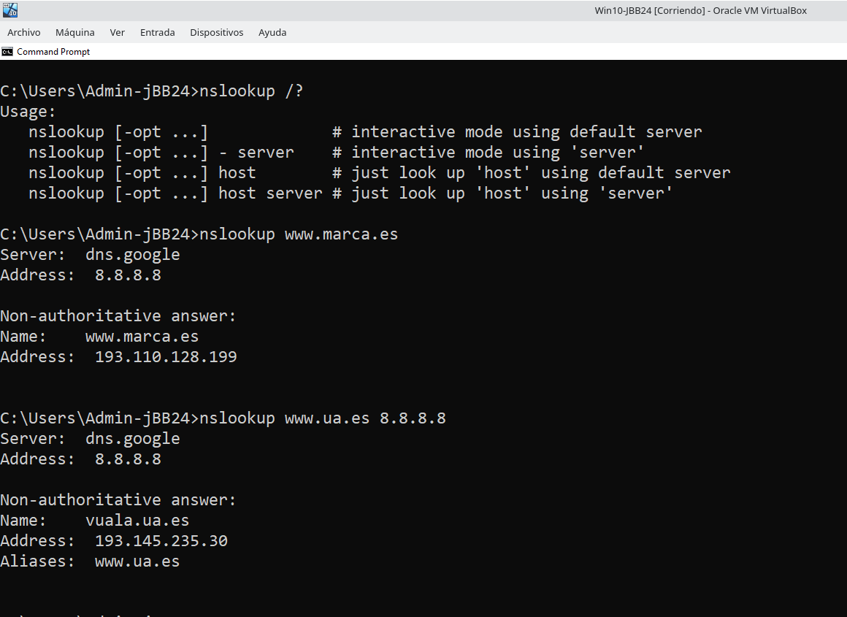
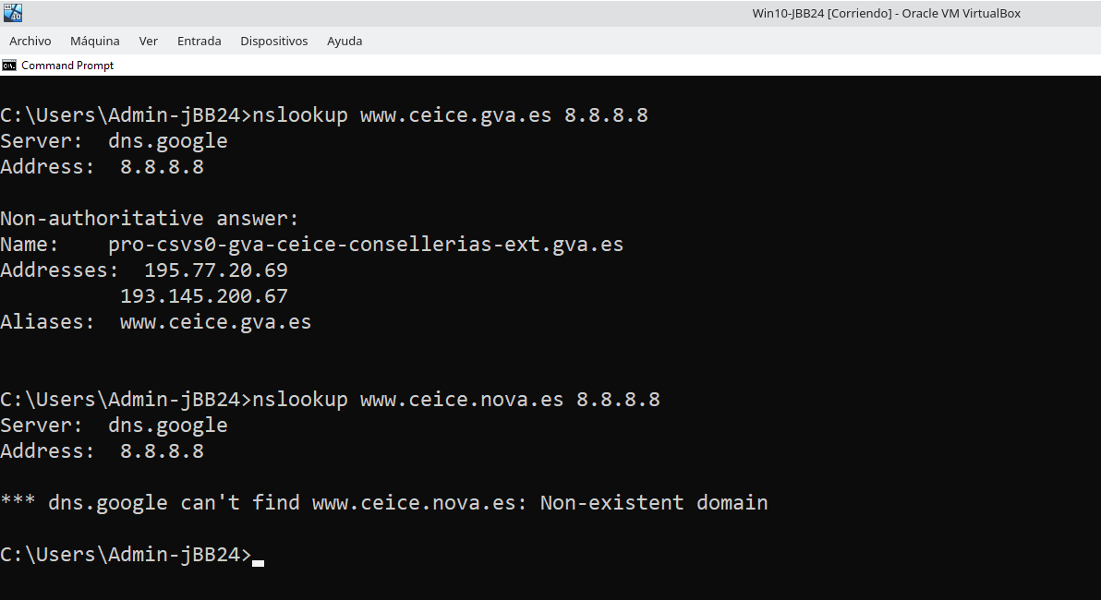

12. Displays NetBIOS over TCP/IP (NetBT) protocol statistics, NetBIOS name tables for the local computer, remote computers, and cache. This command is available only if Internet Protocol (TCP/IP) is installed as a component in a network adapter's properties under Network Connections.

C:\Users\student> nbtstat /?

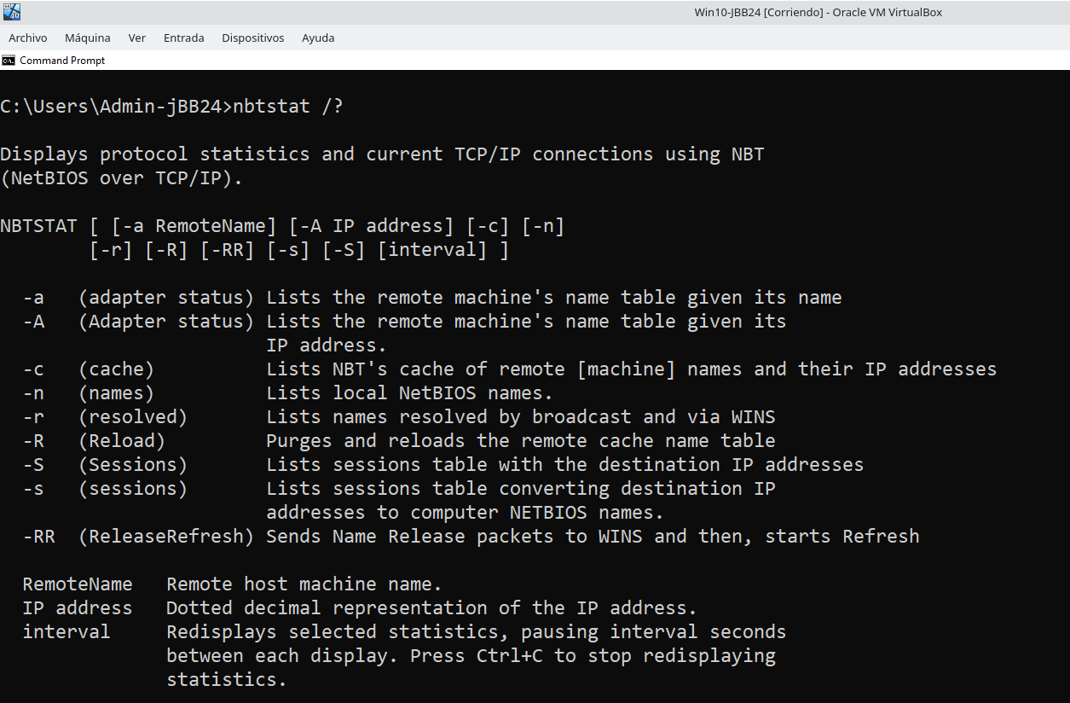

13. Display the NetBIOS name table of the local computer.
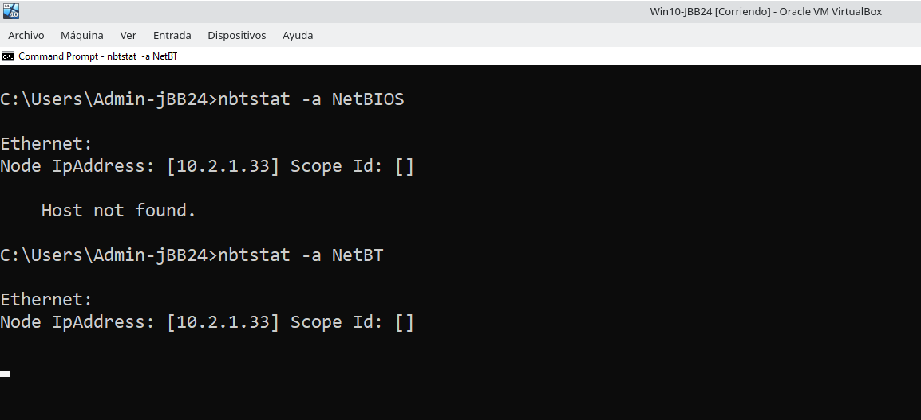

14. Display the contents of the local computer's NetBIOS name cache.

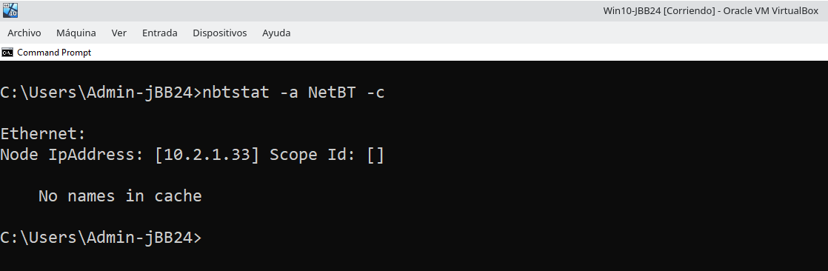

15. Display NetBIOS session statistics by IP address every five seconds, type.
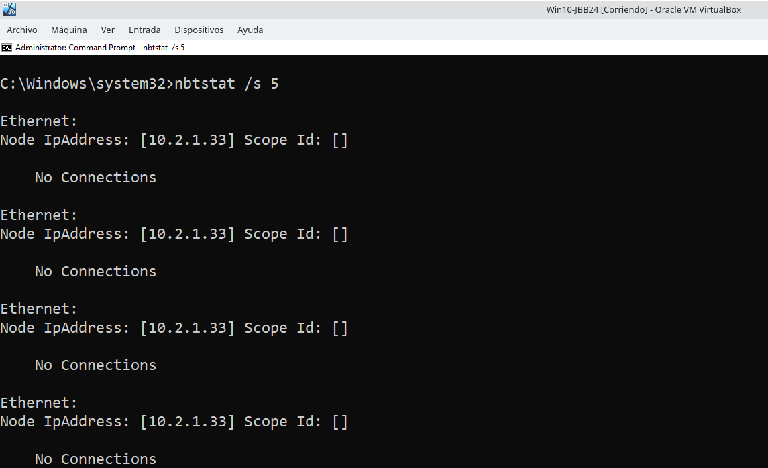

16. Purge the NetBIOS name cache and reload the pretagged entries in the local Lmhosts file, type the following.

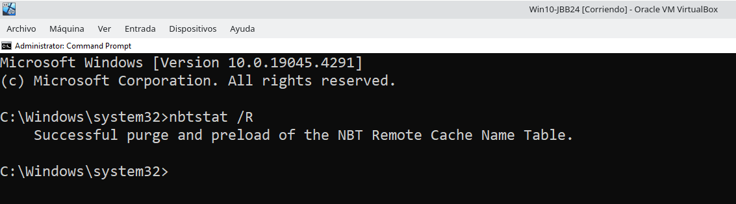
C:\Users\student> nbtstat /R

17. Also, to release NetBIOS names with the WINS server and re-register them.

C:\Users\student> nbtstat /RR

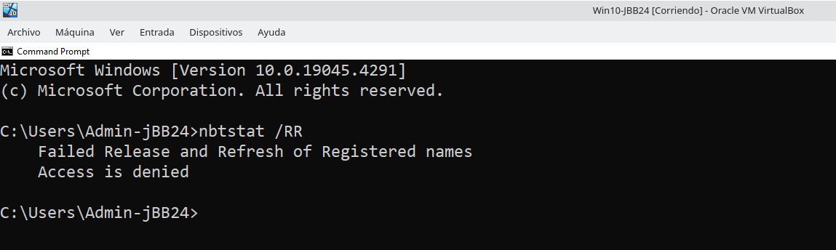

C:\Windows\system32> nbtstat /RR *Administrator’s command line*
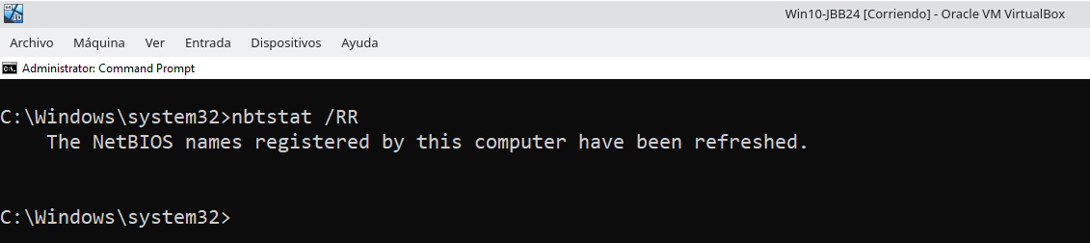

18. Shows active TCP connections, ports the computer is listening on, Ethernet statistics.

C:\Users\student> netstat

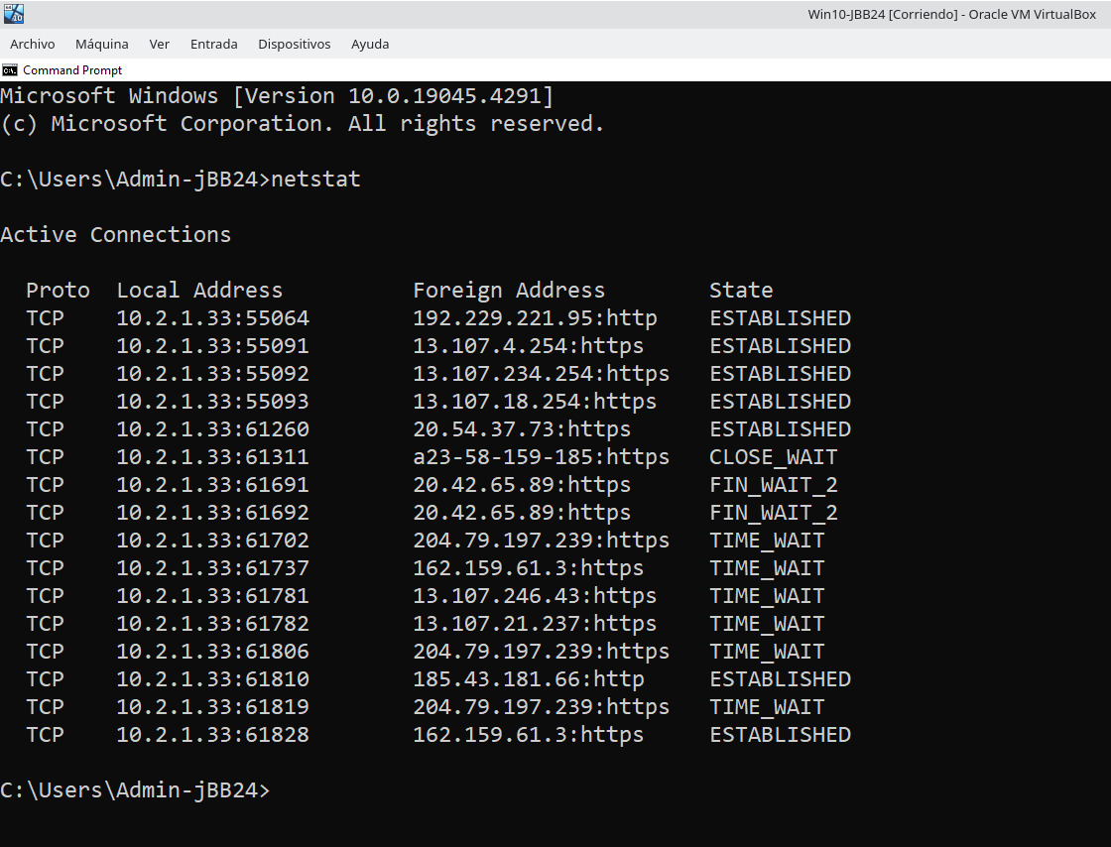

19. Shows IP routing table.
C:\Users\student> netstat -rn
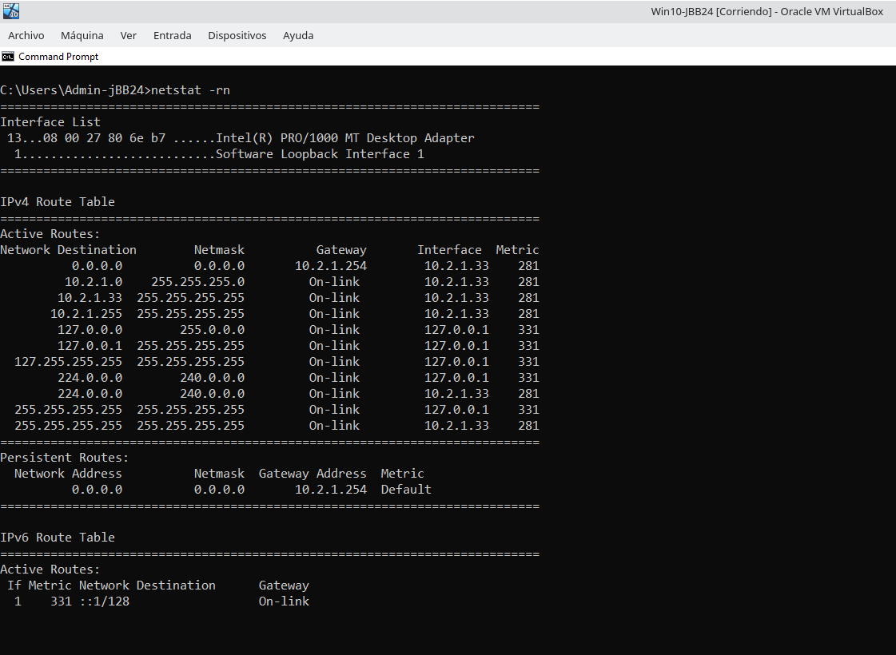

20. Trace the route to follow to reach the hosts called ceice.gva.es, 8.8.8.8 and ua.es.

C:\Users\student> tracert -h 15 ceice.gva.es
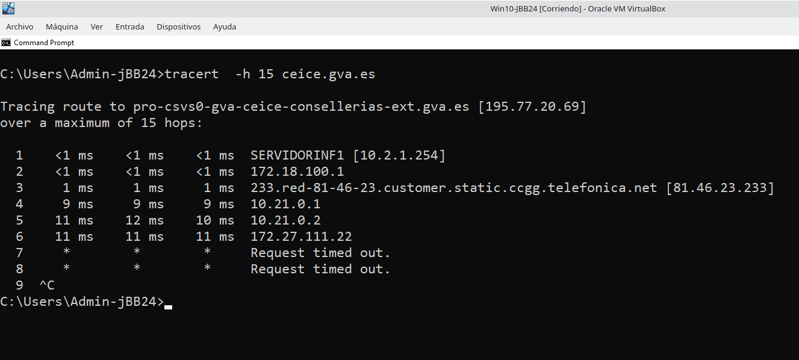
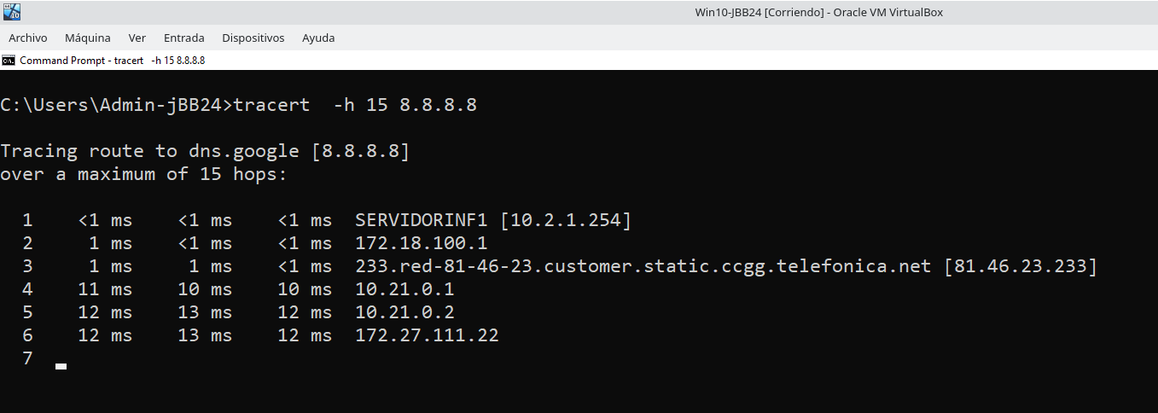

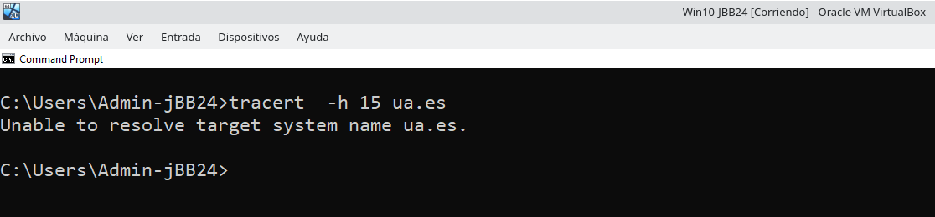
21. Get information about network latency and intermediate hop loss between a source and the
following destinations (ceice.gva.es, 8.8.8.8 and ua.es).

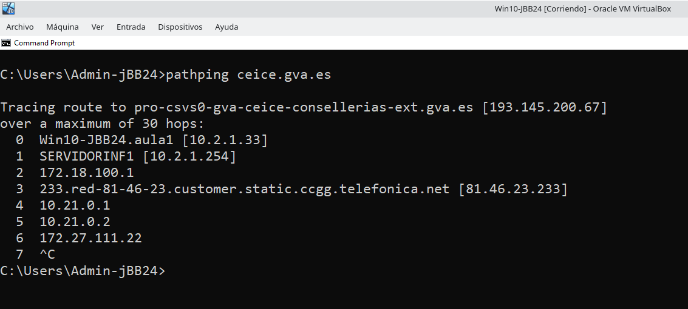
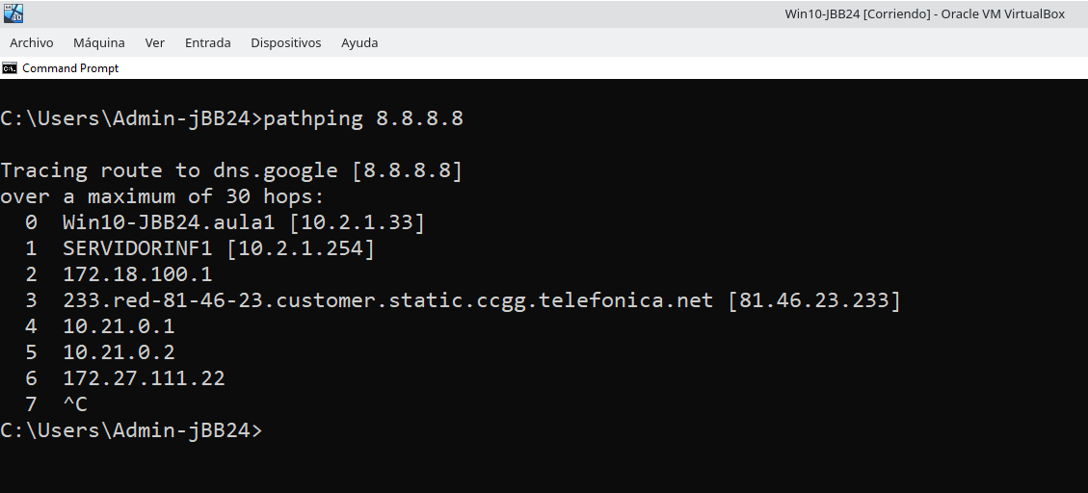
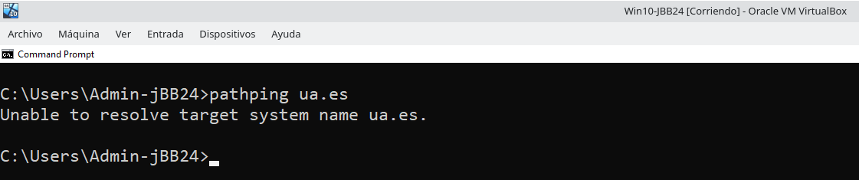
2.4. Sharing folders in Windows.

22. We are going to control the folders that we have shared on the network.
C:\Users\student> net share
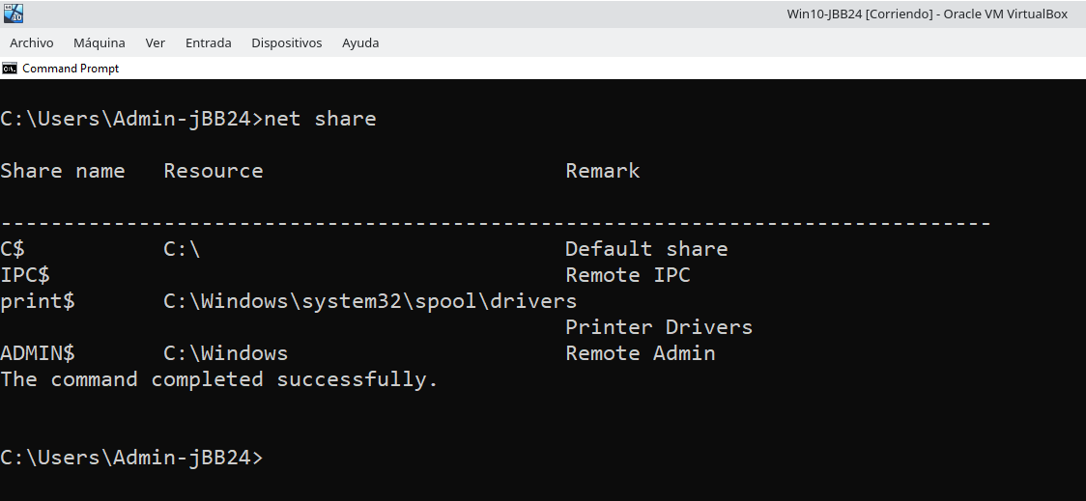
23. We will contrast with the information on shared resources that we can obtain through the graphical interface.(fsmgmt.msc)

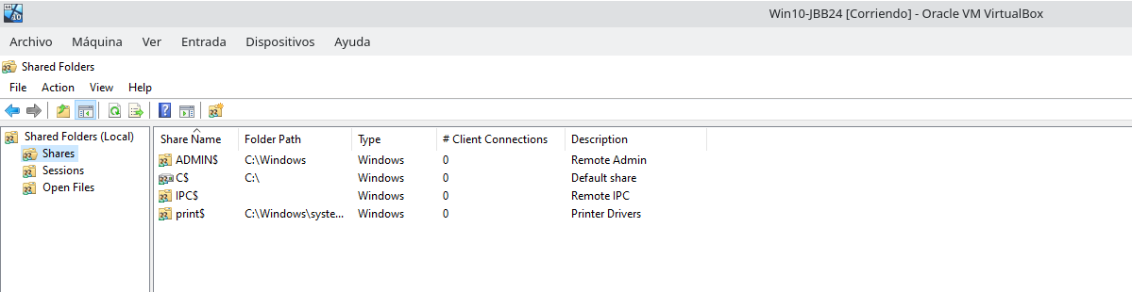

24. We are going to share a network folder with the name Shared-<codId>.
C:\Users\student> net share /?
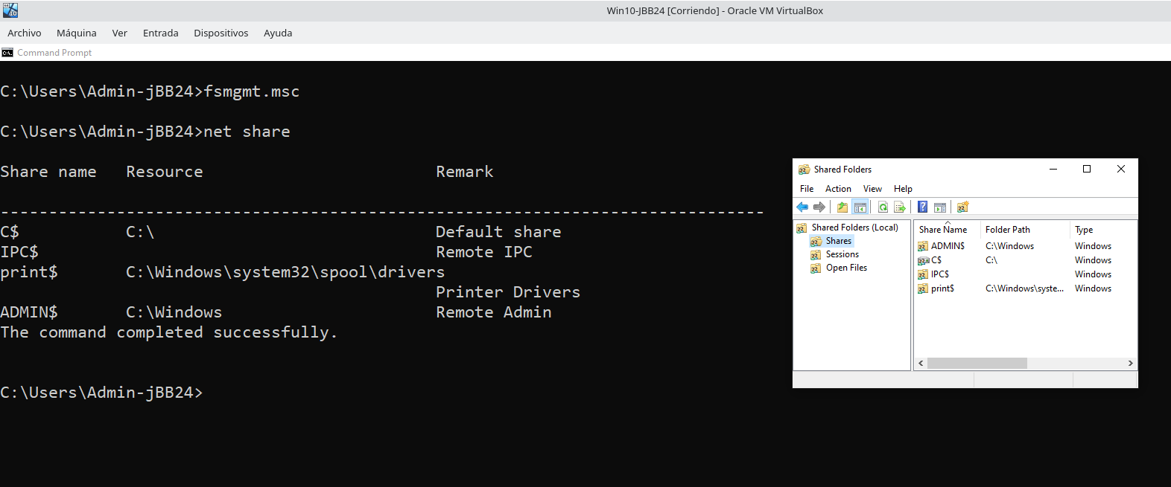
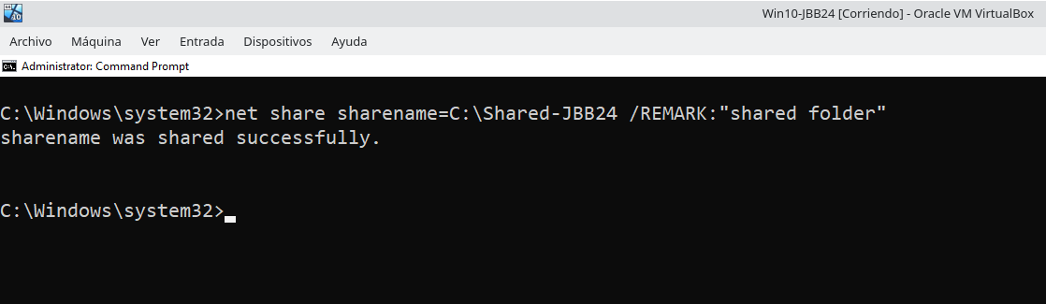
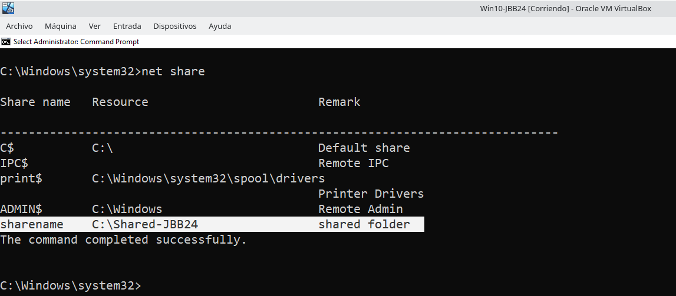

25. From another Windows 10 computer on the network we access the shared folder. And we incorporate the shared folder as a network drive.

C:\Users\student> net use /?
C:\Users\student> net use * \\IP_address\Shared-<codId>

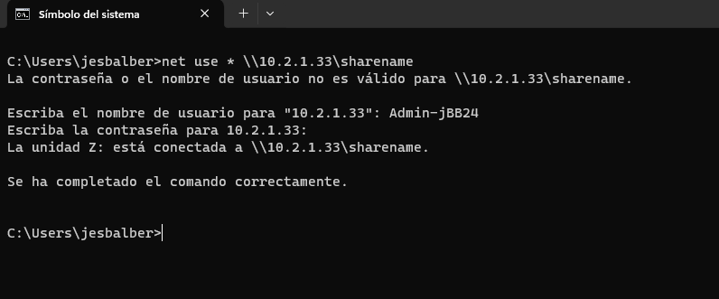

26. We write a text file called README-<codId>.txt in the network drive.

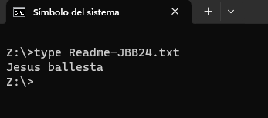

27. We delete the network drive.

C:\Users\student> net use Z: /delete
C:\Users\student> net use

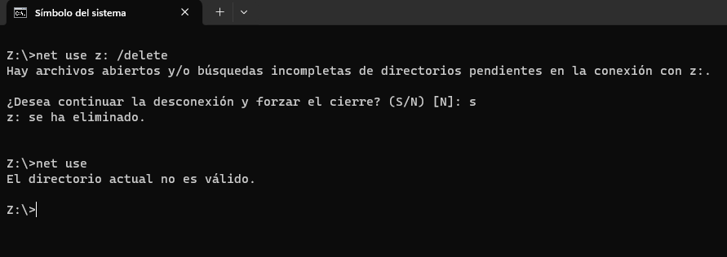

28. We stopped sharing the Shared-<codId> folder.

C:\Windows\system32> net share Shared-<codId> /delete

C:\Windows\system32> net share

C:\Windows\system32> fsmgmt.msc

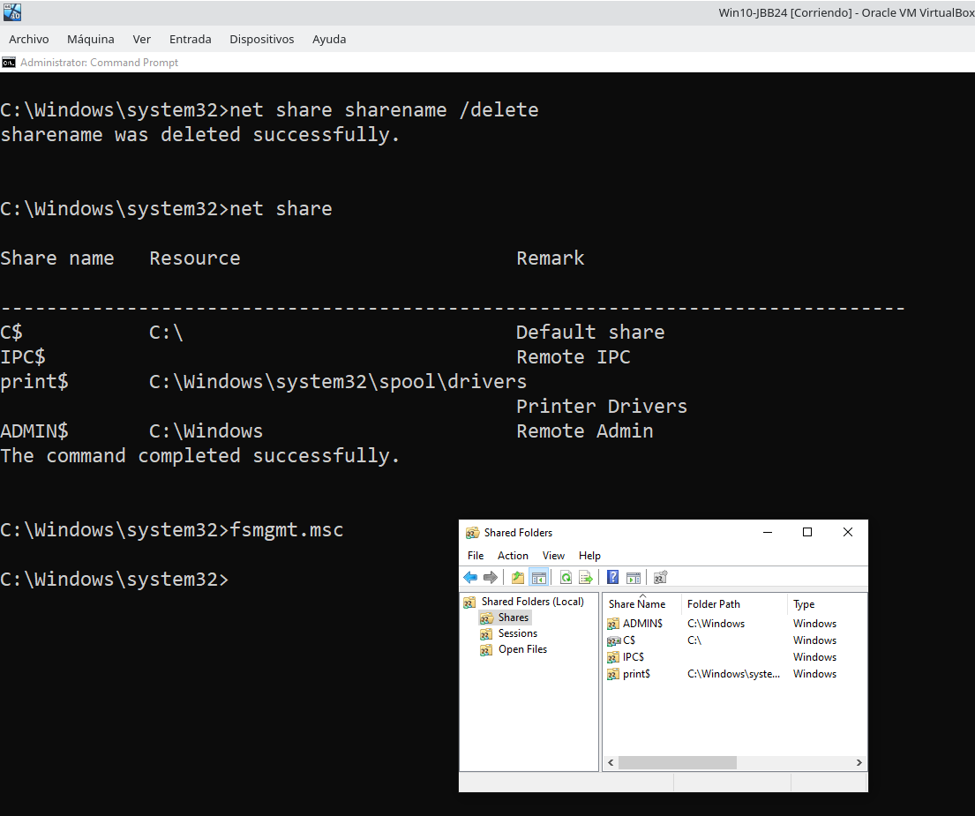

29. We turn off the machine.

C:\Users\student> shutdown /

